Visualization of Model Error
Joshua McClintic

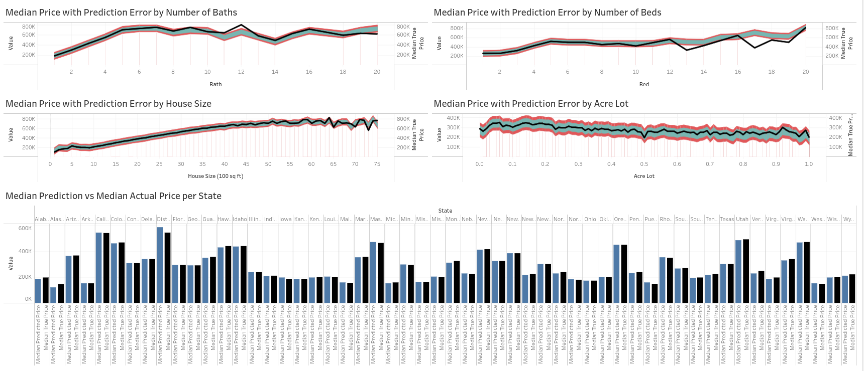
https://public.tableau.com/app/profile/joshua.mcclintic/viz/Wgu_project2/Dashboard1

Linked, and shown, above is a Tableau public page designed to visualize the amount of error made by the model. After using an online color blindness simulator (https://asada.website/webCVS/), The colors here have been determined to not pose an issue. If you still struggle to perceive the colors, go to the issues tab in the GitHub repository this document was found in (https://github.com/JoshuaMcClintic/WGU_Capstone) and create a new issue.

Overview

There are 5 visualizations this document will go over. The first is the bar graph shown above, which shows the median prediction made by the model in blue, and the actual median price in black, for each state.

For the others, the black line shows the median home price for each value listed on the X-axis. The inner light-blue bar shows the total median absolute error, and the red bars represent the total mean absolute error. These ranges were created by taking the model’s prediction and adding or subtracting each error. For example, the bottom of the blue bar is the median prediction minus the median absolute error, the bottom of the red bar is the prediction minus the mean absolute error, and the tops of the bars are the predictions plus the different errors. The center of the blue bar is what the model actually predicted.

There is not a line showing the predicted price for two reasons: The first is that it could make the graphs harder to read by adding a second line that, at many points, is very close to the black line. The second reason is that it is surprisingly difficult to create the graphs in this way in Tableau, and there is a chance that it is not even possible to add another line to the graphs as they currently are (at least in Tableau public; this specific aspect could be a lot easier in matplotlib, but other parts of the graphs would likely be much harder).

Model Metrics

Median Absolute Error (Inner blue bar): +/- 44,765.00
Mean Absolute Error (Outer red bar): +/- 74,745.98

It is important to note that, since the median absolute error is 44,765.00, the vertical range of the inner blue bar is 89,530, and the total error range, which is denoted by the outer red bars, is 149,491.96. This may seem like a very large number, but keep in mind that, at least for more reasonable values, the black median actual price tends to lie right in the middle of the error bars, meaning that, for lower values of the features, the median prediction is about the same as the median actual price.

Median Prediction vs Median Price per State
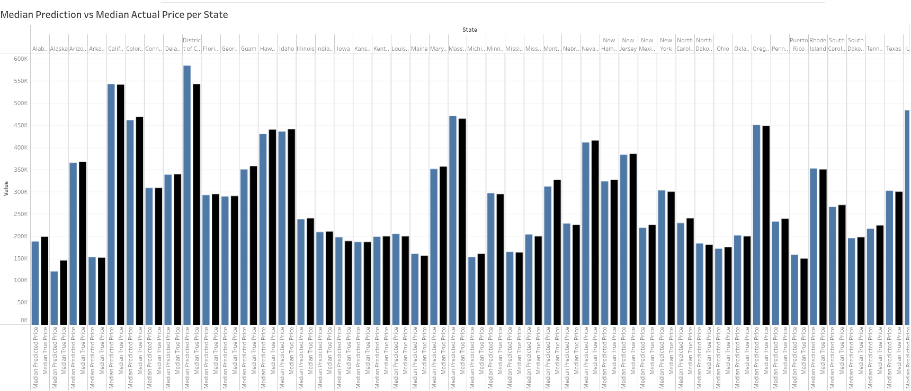
https://public.tableau.com/app/profile/joshua.mcclintic/viz/MedianPredictionvsMedianActualPriceperState/MedianPredictvsTruebyState

Unfortunately, this graph is somewhat difficult to see as an image, so I would recommend using the link. Also, not all of the states are listed in the image, as it needs a horizontal scroll wheel on the original Tableau page, though only when you select its tab. On the full dashboard, you can see each state, though the names get cut off. Fortunately, it’s ordered alphabetically, so it shouldn’t be too difficult to find which state you are looking for, and you can see the state’s full name by hovering over the cutoff name.

For each state, the first (blue) bar is the median predicted price, and the second (black) bar is the actual median price of that state. For each state, these values are quite close.

One notable thing about this particular graph is that by clicking on the name of a state, you can filter the other graphs to only show the model’s performance on that state.

Model Prediction Error on Number of Baths
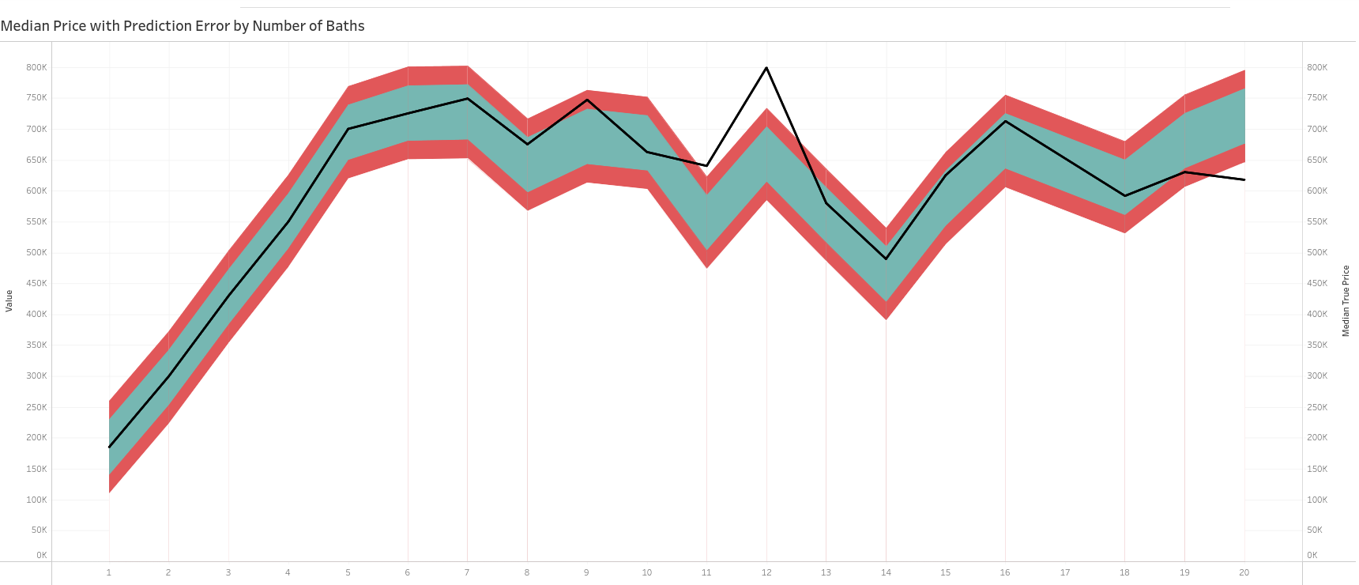
https://public.tableau.com/app/profile/joshua.mcclintic/viz/MedianPricewithPredictionErrorbyNumberofBaths/Bath

Each X-tick represents a difference of 1 bath, with the origin being 0, and the highest tick being 20. Each y-tick represents a difference of $100k USD, with the origin being 0, and the highest tick being $800k.

As we can see, and this is a common trend with the model, for the first few values of number of baths, the model’s median prediction is very close to the actual median prices. Once we start getting to above 7, the data stops being so smooth, instead becoming quite jagged, and the model begins to struggle to keep up. After houses start having more than 9 baths, the actual median price of houses start falling outside even the model’s mean absolute error. Notably, however, 7 baths is a lot of baths, and I would generally consider more than 4 baths to be unreasonable. As such, this loss in performance at large numbers of baths is not a significant issue.

Model Prediction Error on Number of Beds

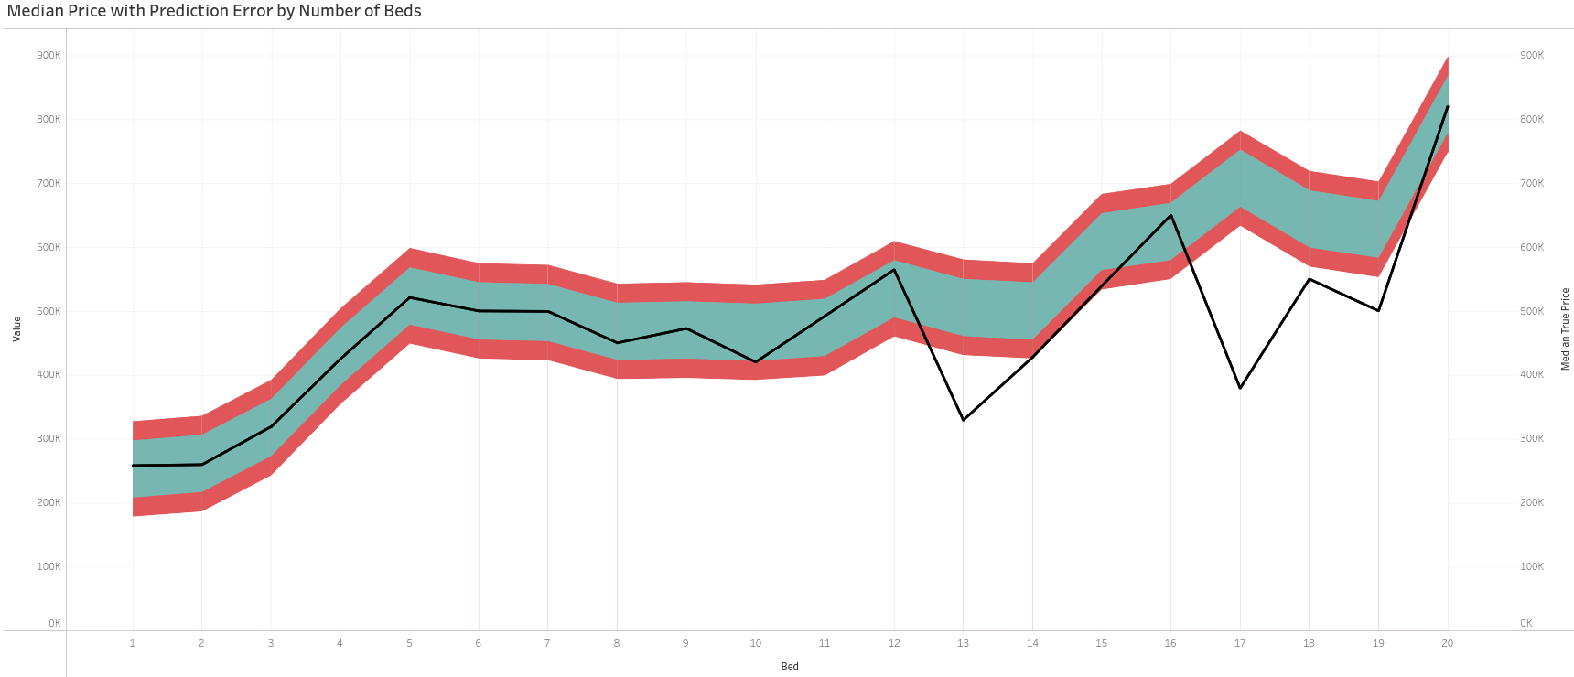
https://public.tableau.com/app/profile/joshua.mcclintic/viz/MedianPricewithPredictionErrorbyNumberofBeds/Bed

As with the previous, each X-tick represents a difference of 1 bed, with an origin of 0, and the highest tick being 20. Each y-tick, however, represents a difference of $50k USD, with an origin of 0, and the highest tick being $700k. By looking at the two graphs side-by-side, we can infer that the number of beds represents less variance in price compared to the number of baths. This may be due to how baths also require plumbing or other services, or perhaps the fact that the number of baths is a set, objective number, while “beds” is a somewhat nebulous category, as a room could be considered a bedroom, or it could be considered a study, or work room, or play room, etc. That is, the number of bedrooms could be subjective.

Just like with the number of baths, the model does well with lower numbers of bedrooms, but starts to struggle as the data becomes more jagged. This change happens around 14 bedrooms, which is also a somewhat unreasonable amount.

Model Prediction Error on House Size
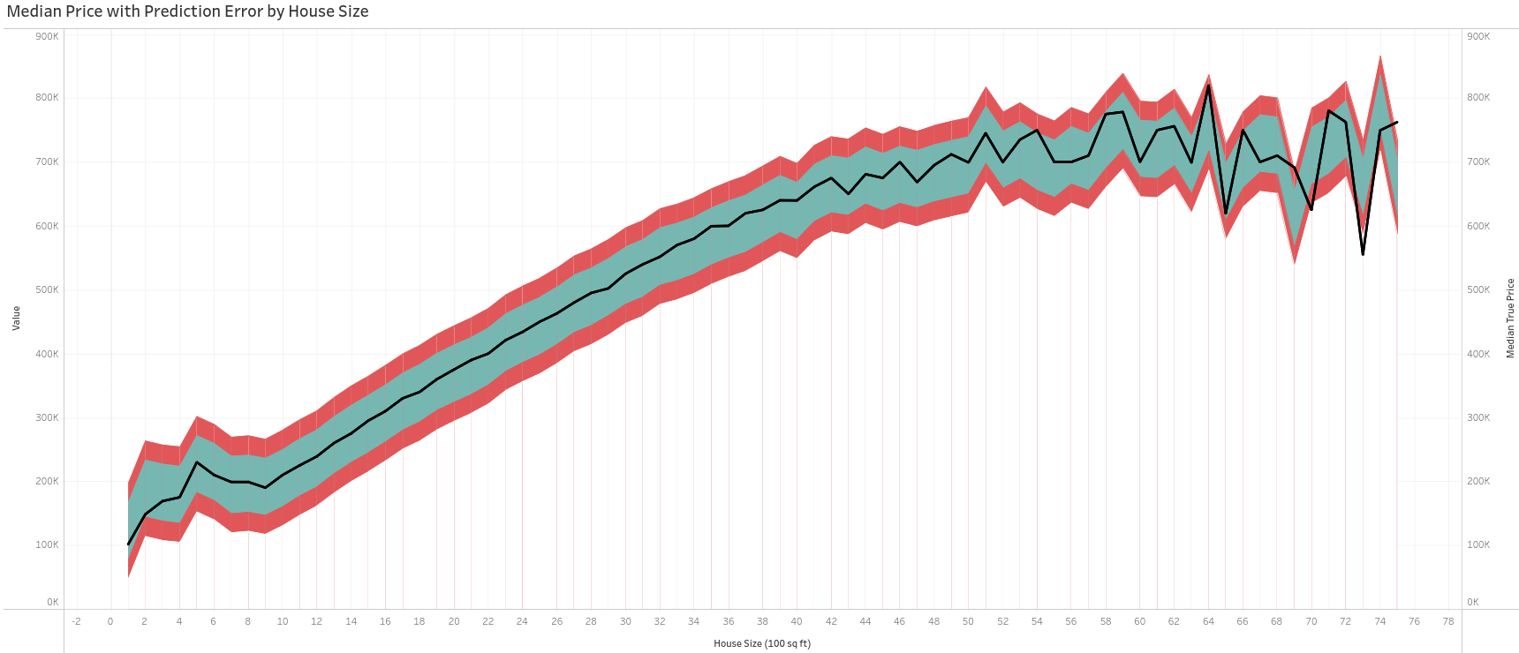
https://public.tableau.com/app/profile/joshua.mcclintic/viz/MedianPricewithPredictionErrorbyHouseSize/HouseSize

For this one, the X-ticks represent house size, with each X value representing a difference of 200 sq ft, from 0 to 75. Each X value is 2 ticks, so each tick is 100 sq ft. The y-ticks represent a difference of $100k USD, with a range of $0 to $900k.

Here, unlike the previous two, the model struggles with very low house sizes, stabilizing at around 400 sq ft. The rest is just like before, however, with lower house sizes having fairly accurate predictions, but as the data becomes more jagged near the high end, the model quite heavily struggles. This begins around 6,000 sq ft, which is quite a large house.

Importantly, house size specifically represents the square footage of the actual building. Acre lot represents the size of the lot the building rests on.

Model Prediction Error on Acre Lot
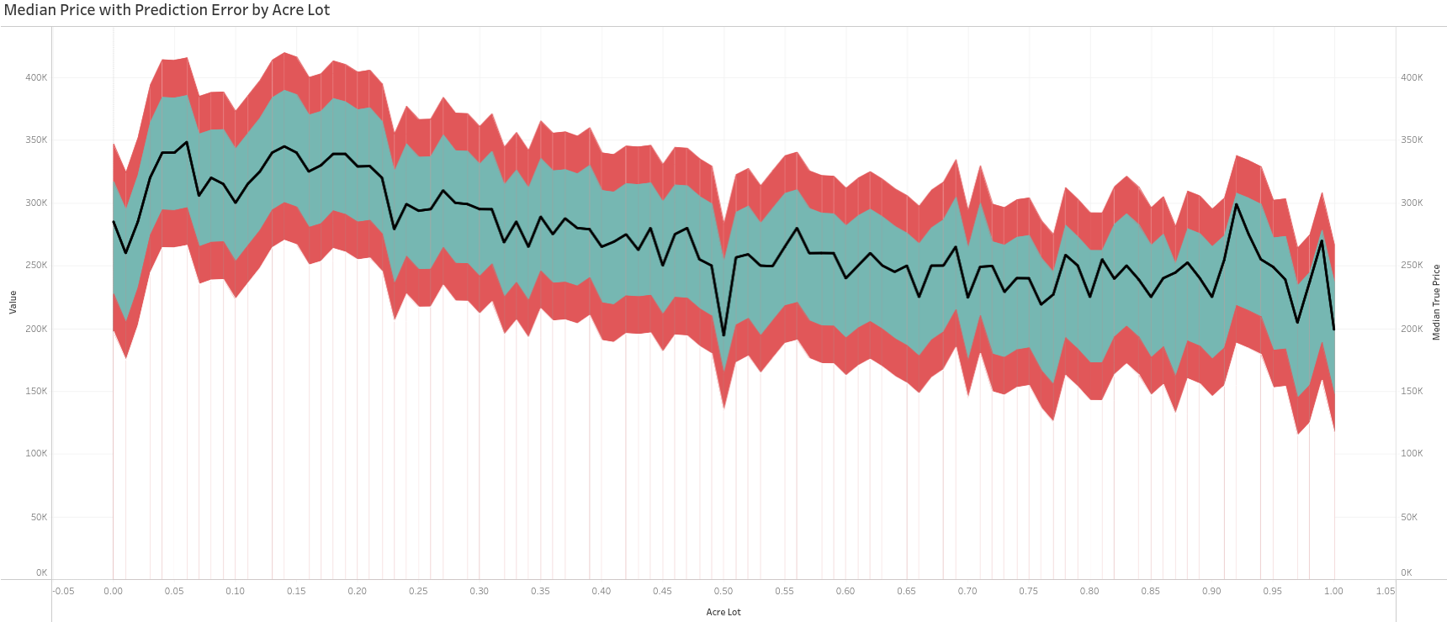
https://public.tableau.com/app/profile/joshua.mcclintic/viz/MedianPricewithPredictionErrorbyAcreLot/AcreLot

For this one, each value on the X-axis shows 0.05 acres, with a range of 0 to 1 acre. For each value shown, there are 5 ticks, so each individual tick is 0.01 acres. Each y-tick represented a difference of $50k, with a range of $0 to $400k.

The median price of a house does not seem to change much based on the size of the lot. However, it does seem like houses with smaller lot sizes seem to be more expensive. After a bit of quick research, I came across an article from April, 2026 (https://acrestosquarefeet.com/for-real-estate, no author given) in which houses with lots of 0.05 to 0.1 acres tend to be in dense urban cities, such as New York, Chicago, etc, and houses with lots of 0.15 to 0.25 acres are typically suburban homes. Now, these prices are starting make sense. Smaller acre lots tend to be for more densely packed houses, usually in dense urban, and often quite expensive, cities, and just above that is the lot size of suburban homes, which have historically been heavily marketed as integral to the American dream, bringing up images of a white picket fence and the concept of the nuclear family. As such, its easy to imagine that demand for these suburban homes tends to be high here in the US, so prices also tend to be high.

